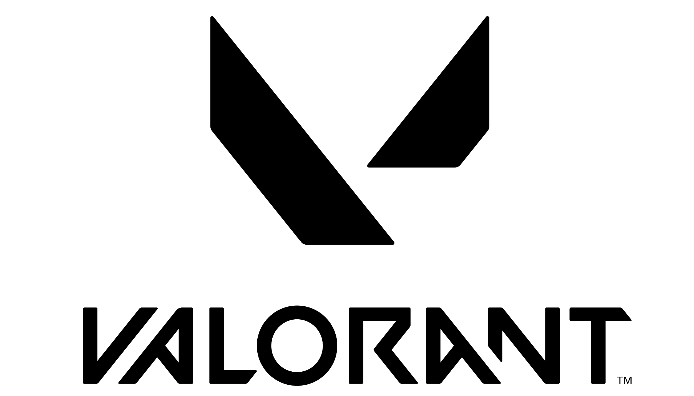

FACT SHEET - EPISODE 5, ACT I BATTLEPASS

Key Features
Battlepass
- Price: 1,000 VP

Free Highlights:
- Shimmer Classic
- Operation: Vacation Player Card
- That’s a Blowout Spray
- Perfect Pattern Gun Buddy

Paid Highlights:
- Task Force 809 Knife
- Task Force 809 Phantom
- Spitfire Operator
- Enter the Duelists Player Card
- Never Forget Leg Day Spray
- Cat Tactics Gun Buddy

Developer/Publisher: Riot Games

Release Date: 6/22/22

